# Class21. SharePoint and js jQuery REST API

# Functions:

# Alert()

# Confirm()

# Prompt()

# Date()

# Console.log()

# Document/DOM

# 

# DOM element = h1, h2, h3, …

# The whole things are called window

# Window.alert() or alert()

<html lang="en">

<head>

    <meta charset="UTF-8">

    <meta name="viewport" content="width=device-width, initial-scale=1.0">

    <meta http-equiv="X-UA-Compatible" content="ie=edge">

    <title>Document</title>

</head>

<body>

    <h1 onclick="alert ('you clicked me')"> Some text</h1>

    <input type="button" value="Function called" onclick="calculateAge('3/3/2000')">

    <script>

        function calculateAge(dob){

            console.log("Function is called");

        }

    </script>

</body>

</html>

# 

# Object:

# Is things with many properties

# Eg. Date , Car , person..

# (new Date())

# Mon Feb 03 2020 18:30:49 GMT-0500 (Eastern Standard Time)

# (new Date()) .getDay()

# 1

# (new Date()) .getMonth()

# 1

# (new Date()) .getFullYear()

# 2020

<body>

    <h1 onclick="alert ('you clicked me')"> Some text</h1>

    <input type="button" value="Call function" onclick="calculateAge('3/3/2000')">

    <script>

        function calculateAge(dob) {

            var d = new Date(dob);

            var today = new Date();

            var age = today.getFullYear() - d.getFullYear();

            alert("your age is " + age);

        }

    </script>

</body>

# Function may return the value or may not return the value

**Example: Alert doesn’t return anything**

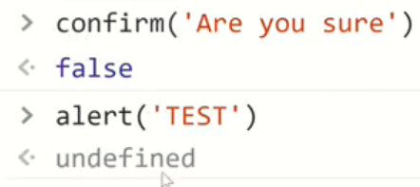

**Object:**

  <p>=====Ex2:=======</p>

    <script>

        function calculateAge(dob) {

            var d = new Date(dob);

            var today = new Date();

            var age = today.getFullYear() - d.getFullYear();

            return age;

        }

        var st1 = {

            name: 'Belew',

            email: 'belachew@gmail.com',

            dob:'2/3/1985',

            phone:'333-444-3445'

        };

    </script>

1. st1
2. [object Object]: {dob: "2/3/1985", email: "belachew@gmail.com", name: "Belew", phone: "333-444-3445"}

dob: "2/3/1985"

email: "belachew@gmail.com"

name: "Belew"

phone: "333-444-3445"

__proto__: Object

1. st1.name
2. "Belew"

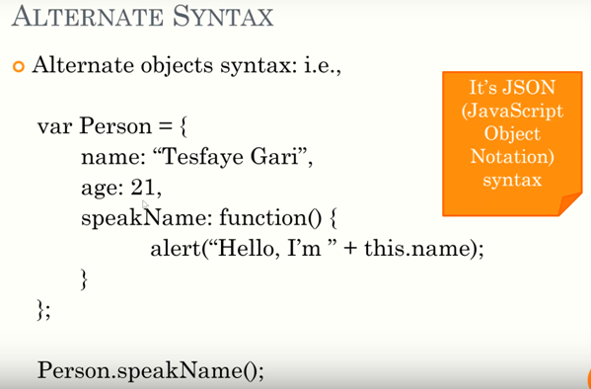

**Json: (JavaScript Object Notation)**

**Use IE**

**//to convert js object to Json: JSON.stringfy(st1);**

1. **st1   
   [object Object]: {dob: "2/3/1985", email: "belachew@gmail.com", name: "Belew", phone: "333-444-3445"}**
2. **JSON.stringify(st1)   
   "{"name":"Belew","email":"belachew@gmail.com","dob":"2/3/1985","phone":"333-444-3445"}"**

Json object to Js object:JSON.parse(jsonSt1);

1. **jsonSt1   
   "{"name":"Belew Abebe","email":"belachew@gmail.com","dob":"2/3/1985","phone":"333-444-3445"}"**
2. **JSON.parse(jsonSt1)   
   [object Object]: {dob: "2/3/1985", email: "belachew@gmail.com", name: "Belew Abebe", phone: "333-444-3445"}**

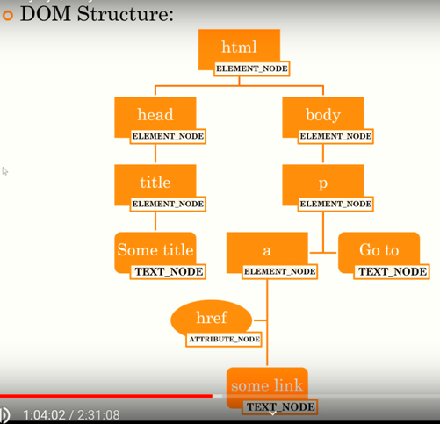

**The above whole html structure is called Document.**

**Our visual studio also has tree like structure**

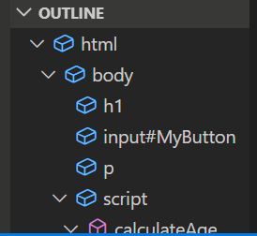

**Document: use Google chrome.**

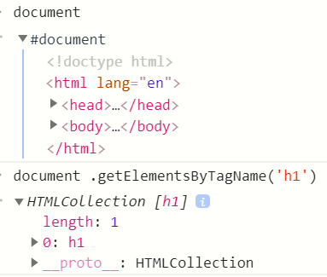

1. **Use IE**

**document.getElementById('MyButton')   
<input id="MyButton" onclick="calculateAge('3/3/1980')" type="button" value="Call function"></input>**

**jQuery($):** => document.getElementById('MyButton')  represente by $('MyButton')

To do wwith jQuery we need bring the flowing jQuery link from our previous Bootstrap and put it between title and head.

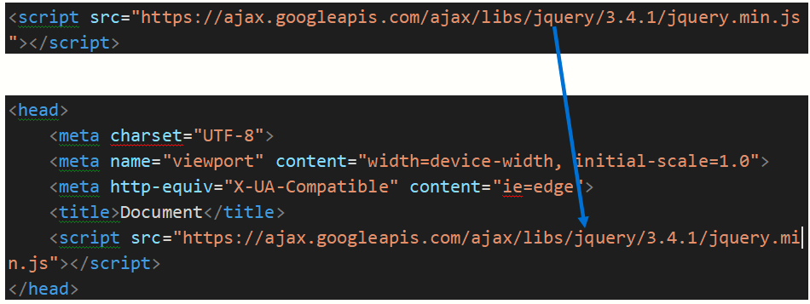

**Chrome is prefer able to**

1**. $('#myButton')**

k.fn.init [input#myButton]0: input#myButtonlength: 1__proto__: Object(0)

**2. $('#myButton') .hide()**

k.fn.init [input#myButton]

**3. $('#myButton') .show()**

k.fn.init [input#myButton]

**After this we get Actual practice:**

 <link rel="stylesheet" href="https://maxcdn.bootstrapcdn.com/bootstrap/4.4.1/css/bootstrap.min.css">

  <script src="https://ajax.googleapis.com/ajax/libs/jquery/3.4.1/jquery.min.js"></script>

  <script src="https://cdnjs.cloudflare.com/ajax/libs/popper.js/1.16.0/umd/popper.min.js"></script>

  <script src="https://maxcdn.bootstrapcdn.com/bootstrap/4.4.1/js/bootstrap.min.js"></script>

We put the above links at our function project and add the following

<div class="container-fluid">

    <h1> Some text</h1>

</div>

<input class = "btn btn-primary" id ="myButton" type="button" value="Call function" onclick="calculateAge('3/3/1980')">

And cancel

onclick="calculateAge('3/3/1980')

at the end part of input

**Document ready function:**

$(document).ready(function(){});/ $().xx(f(){yy()});

        //Or

 $(function(){});

Mostly we use

$(document).ready(function(){});

Eg.1

 $('#myButton').click(function(){

        alert('Somebody Button clicked')

        });

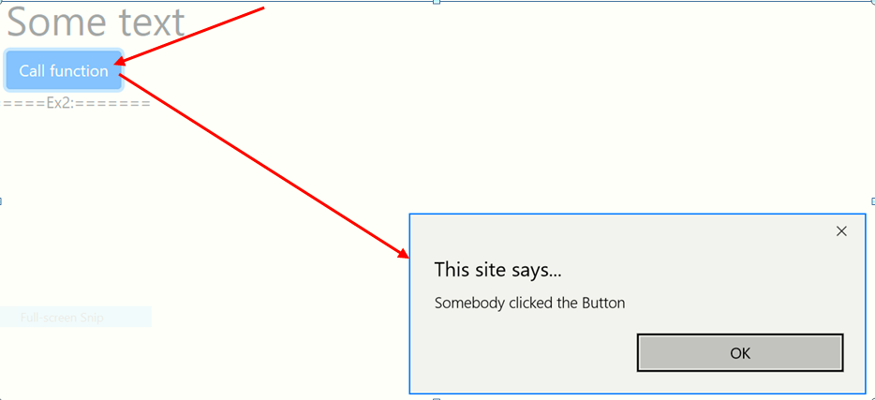

2.To do hide

Instead of

alert('Somebody clicked the Button')

put

$(this).hide()

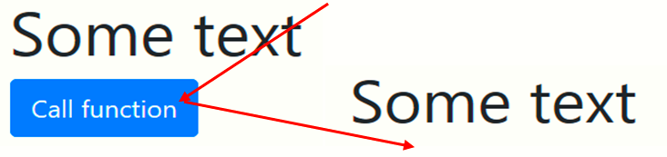

3.To hide h1

$('h1').hide()

4.To Toggle h1

$('h1').toggle()

**REST API**

**Sp USES REST API by using URL and methods(Get, Post,…)**

**URL of sp: url**

**Entry to sp rest: /_api/web**

**Then we use: url + /_api/web**

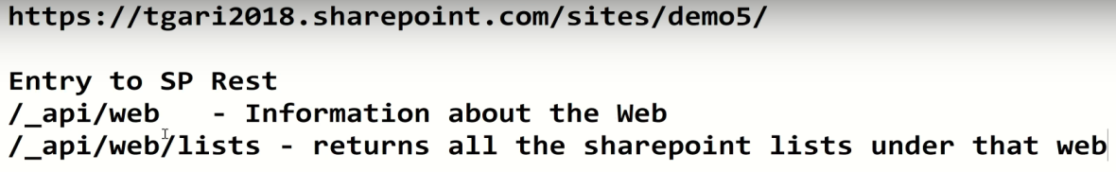

**To Add and Use YARC**

Yarc=>[Yet Another REST Client - Chrome Web Store](https://chrome.google.com/webstore/detail/yet-another-rest-client/ehafadccdcdedbhcbddihehiodgcddpl)=>Add to chrome

<https://nmek.sharepoint.com/sites/Demo/>

**https://nmek.sharepoint.com/sites/Demo/_api/web**

**if we put on the browser: => display XML**

**https://nmek.sharepoint.com/sites/Demo/_api/web/lists =>SP lists and libraries**

**this reads hiden list to.**

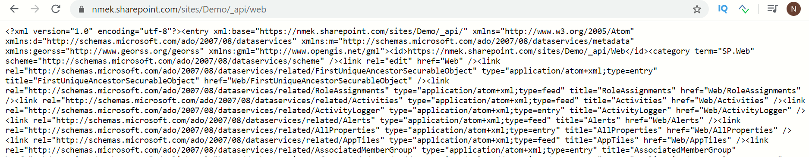

**if we put on the YARC: => it shows all information about site**

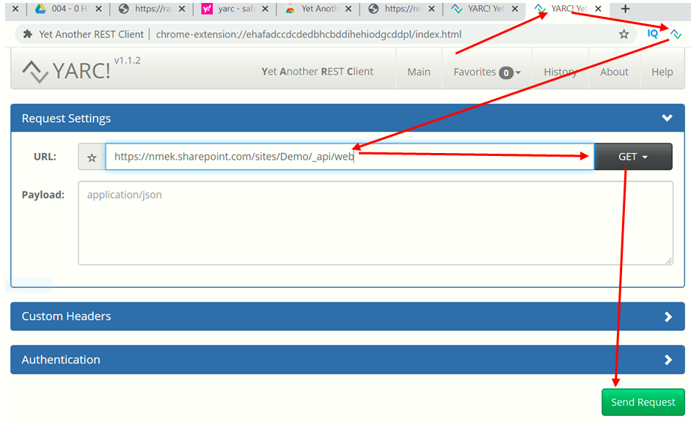

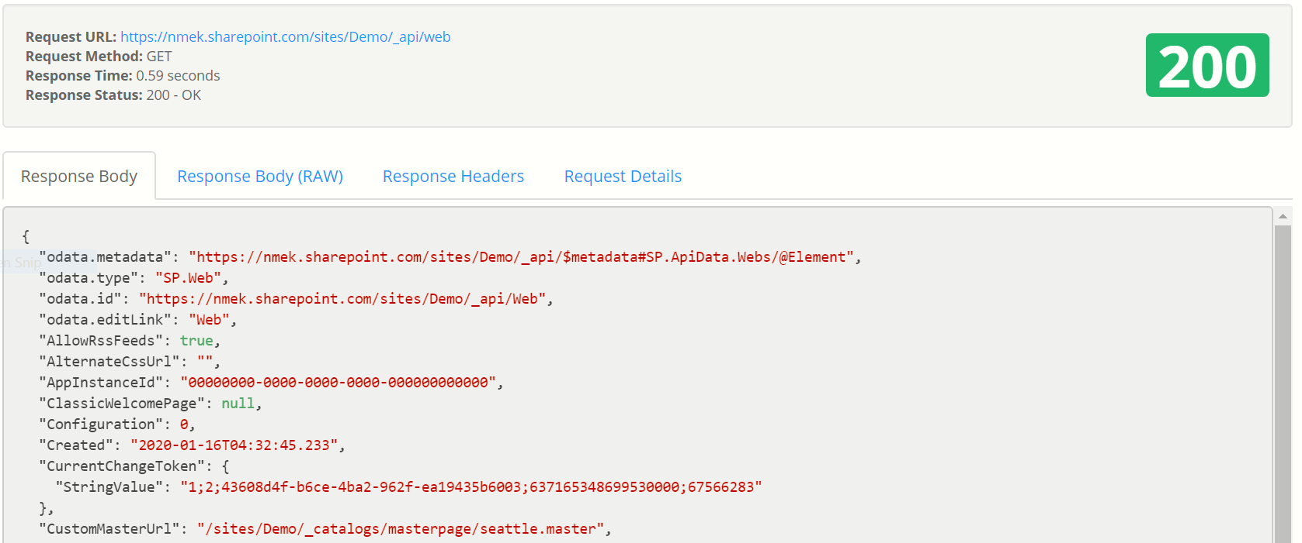

From the above we get:

* "Created": "2020-01-16T04:32:45.233"
* LastItemModifiedDate": "2020-02-05T01:19:04Z",
* "Title": "Home",….

**To Open**

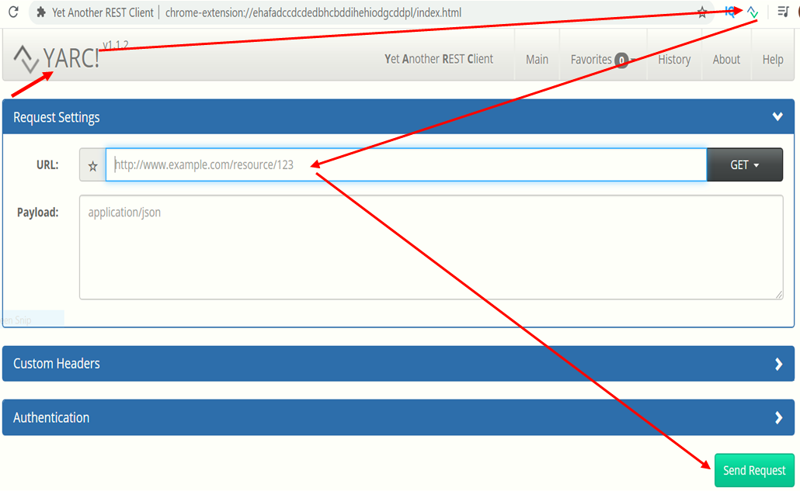

**How do we filter**

**https://nmek.sharepoint.com/sites/Demo/_api/web/lists?$filter =hidden eq false**

**https://nmek.sharepoint.com/sites/Demo/_api/web/lists?$filter =hidden eq false&$select =Title,ItemCount**

**To get one list by title:**

**/_api/web/lists/getbytitle(‘ListName’)**

Eg: [**https://nmek.sharepoint.com/sites/Demo/_api/web/lists/getbytitle('MyProjects')**](https://nmek.sharepoint.com/sites/Demo/_api/web/lists/getbytitle('MyProjects'))

**Send to SharePoint: PracticeJS.html**

**<script src="https://ajax.googleapis.com/ajax/libs/jquery/3.4.1/jquery.min.js"></script>**

**<script src="https://cdnjs.cloudflare.com/ajax/libs/popper.js/1.16.0/umd/popper.min.js"></script>**

**<script src="https://maxcdn.bootstrapcdn.com/bootstrap/4.4.1/js/bootstrap.min.js"></script>**

**<div class="container-fluid">**

**<div id="myItems">**

**</div> </div>**

**<script>**

**function getItems(listName) {**

**var url = _spPageContextInfo.webAbsoluteUrl + "/_api/web/lists/getbytitle('" + listName + "')/items";**

**return $.ajax({**

**url: url,**

**method: "GET",**

**headers: { "Accept": "application/json; odata=verbose" }**

**});**

**}**

**function getLists() {**

**var url = _spPageContextInfo.webAbsoluteUrl + "/_api/web/lists?$filter=Hidden eq false";**

**return $.ajax({**

**url: url,**

**method: "GET",**

**headers: { "Accept": "application/json; odata=verbose" }**

**});**

**}**

**$(document).ready(function () {**

**getLists().then(function (response) {**

**console.log('Data is ', response);**

**}, function (error) { console.log('oops error ', error); });**

**});**

**</script>**

Weget:

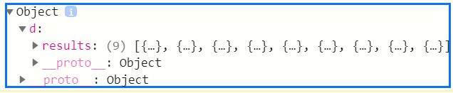

<link rel="stylesheet" href="https://maxcdn.bootstrapcdn.com/bootstrap/4.4.1/css/bootstrap.min.css">

**<script src="https://ajax.googleapis.com/ajax/libs/jquery/3.4.1/jquery.min.js"></script>**

**<script src="https://cdnjs.cloudflare.com/ajax/libs/popper.js/1.16.0/umd/popper.min.js"></script>**

**<script src="https://maxcdn.bootstrapcdn.com/bootstrap/4.4.1/js/bootstrap.min.js"></script>**

**<div class="container-fluid">**

**<div id="myItems">**

**</div>**

**</div>**

**//============================================**

**<script>**

**function getItems(listName) {**

**var url = _spPageContextInfo.webAbsoluteUrl + "/_api/web/lists/getbytitle('" + listName + "')/items";**

**return $.ajax({**

**url: url,**

**method: "GET",**

**headers: { "Accept": "application/json; odata=verbose" }**

**});**

**}**

**function getLists() {**

**var url = _spPageContextInfo.webAbsoluteUrl + "/_api/web/lists?$filter=Hidden eq false";**

**return $.ajax({**

**url: url,**

**method: "GET",**

**headers: { "Accept": "application/json; odata=verbose" }**

**});**

**}**

**$(document).ready(function () {**

**getLists().then(function (response) {**

**console.log('Data is ', response);**

**var lists = response.d.results;**

**for(var index in lists)**

**{**

**console.log(lists[index].Title, lists[index].ItemCount); }**

**}, function (error) { console.log('oops error ', error); });**

**});**

**</script>**

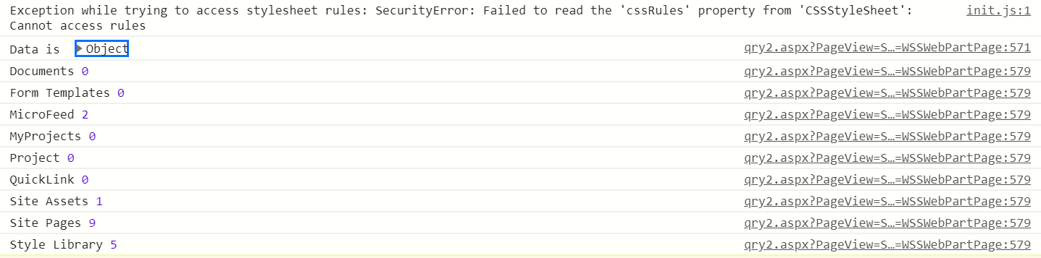

And then:

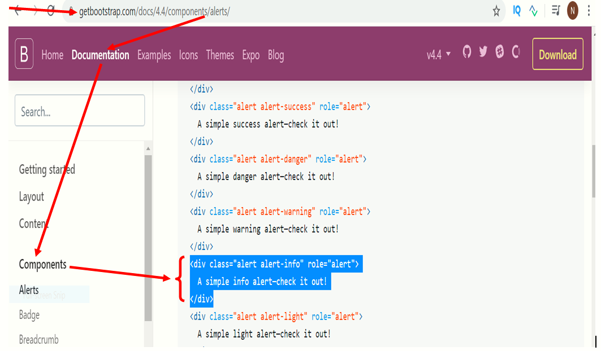

<link rel="stylesheet" href="https://maxcdn.bootstrapcdn.com/bootstrap/4.4.1/css/bootstrap.min.css">

<script src="https://ajax.googleapis.com/ajax/libs/jquery/3.4.1/jquery.min.js"></script>

<script src="https://cdnjs.cloudflare.com/ajax/libs/popper.js/1.16.0/umd/popper.min.js"></script>

<script src="https://maxcdn.bootstrapcdn.com/bootstrap/4.4.1/js/bootstrap.min.js"></script>

<div class="container-fluid">

    <div id="myItems">

    </div>

</div>

<script>

    //Function to get list items by passing List name to the list

    function getItems(listName) {

     var url = _spPageContextInfo.webAbsoluteUrl + "/_api/web/lists/getbytitle('" + listName + "')/items";

        return $.ajax({

            url: url,

            method: "GET",

            headers: { "Accept": "application/json; odata=verbose" }

        });

    }

    function getLists() {

        var url = _spPageContextInfo.webAbsoluteUrl + "/_api/web/lists?$filter=Hidden eq false";

        return $.ajax({

            url: url,

            method: "GET",

            headers: { "Accept": "application/json; odata=verbose" }

        });

    }

    //jQuery document ready, the code in the block runs after html renders

    $(document).ready(function () {

        //Code inplementation goes here

        getLists().then(function (response) {

            console.log('Data is ', response);

            var myHtml = '';

            var lists = response.d.results;

                for (var index in lists) {

                console.log(lists[index].Title, lists[index].ItemCount);

                myHtml = myHtml + `<div class="alert alert-info" role="alert">

                    ${lists[index].Title} - ${lists[index].ItemCount} Items

                     </div>`

                   }

                    $('#myItems').html(myHtml);

        }, function (error) { console.log('oops error ', error); });

    });

</script>

Then we get:

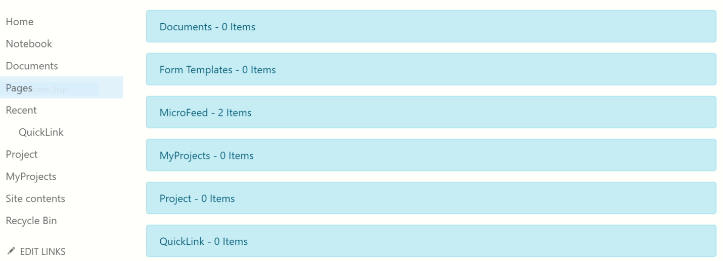

**End of class 21**